**Y.V.N.R. Govt. Degree College, Kaikaluru**

**DEPARTMENT of ECONOMICS**

**Best Practice of the Department**

Cash Award to the Meritorious Student **2019-2020** ,P.Thirupatamma III BA for securing 85% in Economics

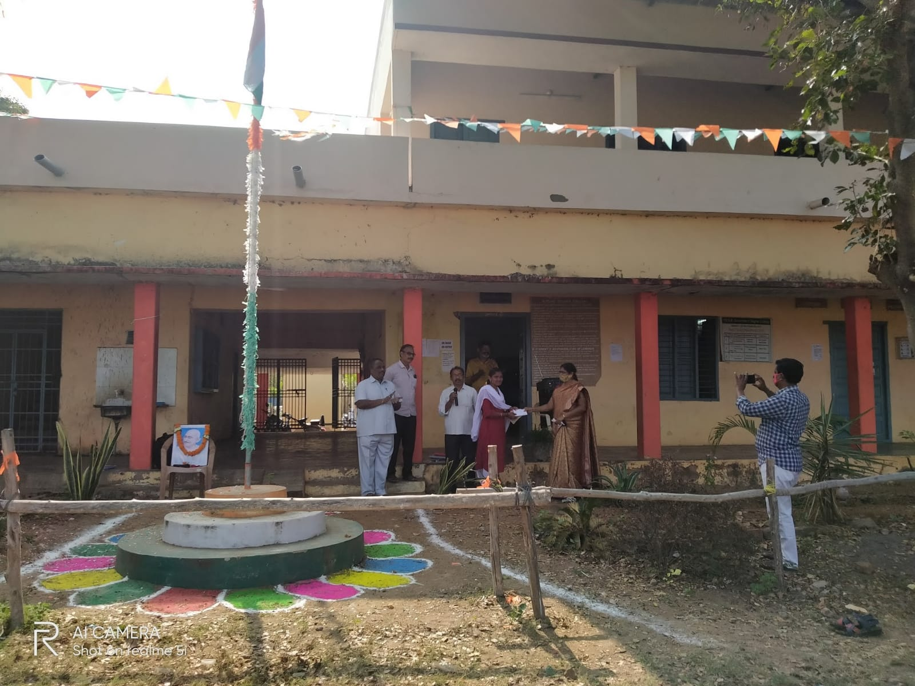

Cash Award to the Meritorious Student **2021-2022** ,P.Rama Devi of III BAfor securing 75% in Economics

